SIMATS ENGINEERING (SAVEETHA SCHOOL OF ENGINEERING)
Course Code & Title: | ECA5604 -5G/6G COMMUNICATION | Course Faculty: | Dr.K.Sathish
Student Name: | Velamuri Bhanodhay | Reg. No.: | 192412330
Dept / Batch: | BE.ECE / 2024 | Date: | 24/8/2026
Lab Observation

Experiment 14 : 5G Throughput vs SNR with Modulation Labels

Objective 1: To evaluate the Throughput (Mbps) of a 5G communication system under different
Signal-to-Noise Ratio (SNR) conditions.

Matlab Code:

clc;clear;close all
S=0:5:30; T=100*(1-exp(-S/10));
disp('SNR(dB) Throughput(Mbps)'),disp([S' T'])
subplot(211)
plot(S,T,'-o','LineWidth',2);grid on
title('5G Throughput vs SNR')
xlabel('Signal-to-Noise Ratio (dB)'),ylabel('Throughput (Mbps)')
subplot(212)
bar(T);grid on
title('Throughput at Different SNR Levels')
xlabel('SNR Index'),ylabel('Throughput (Mbps)')

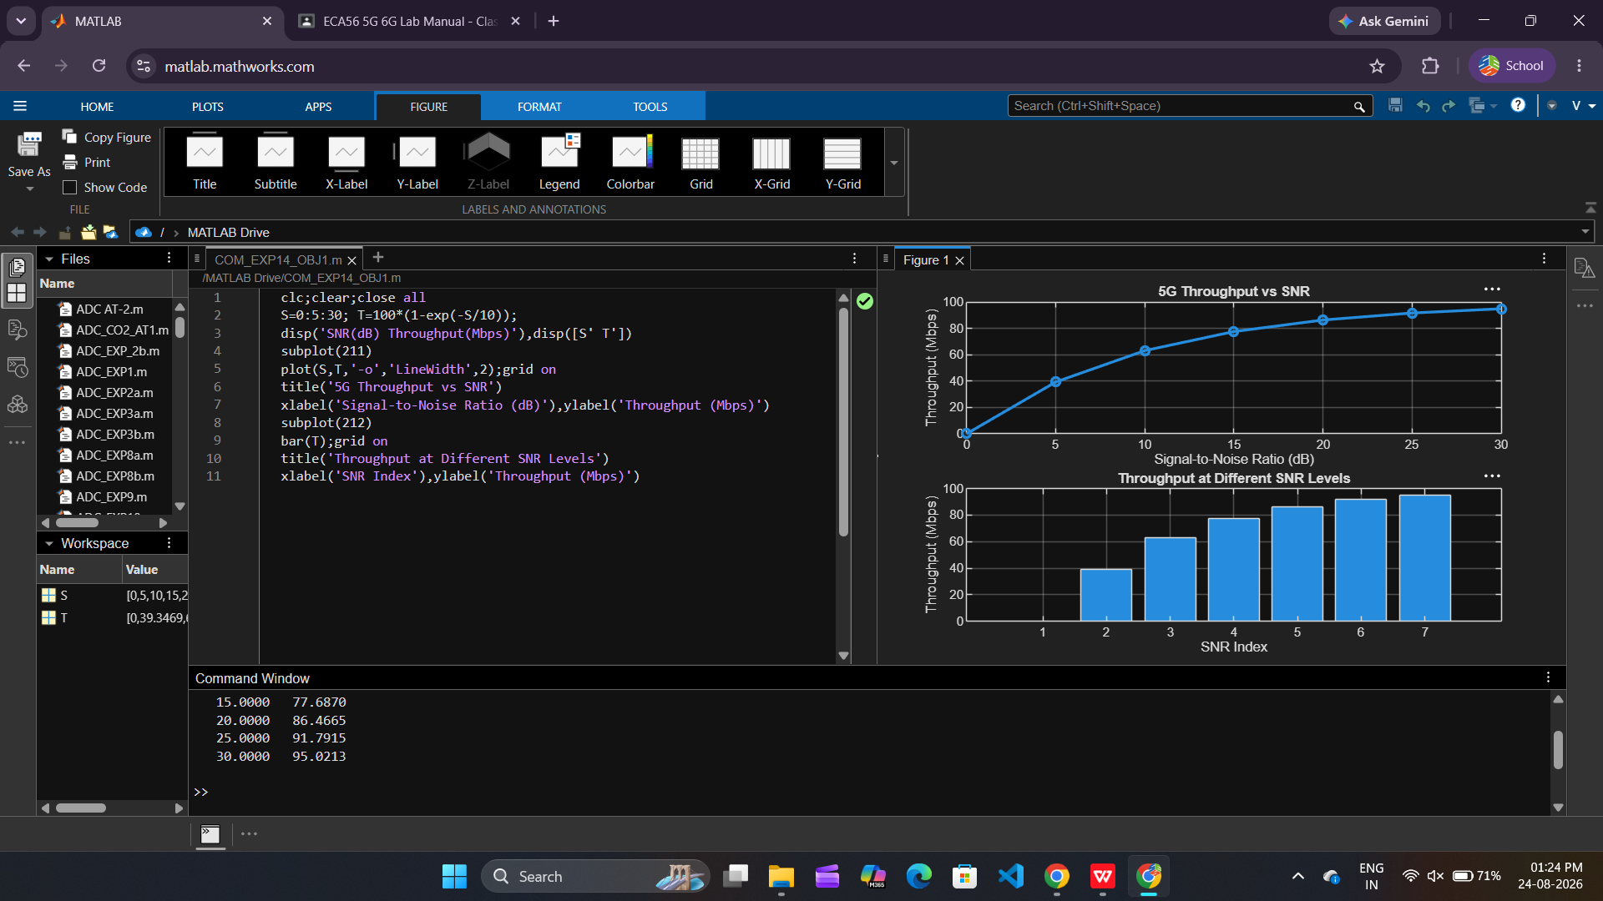

Objective 2: To analyze the effect of Signal-to-Noise Ratio (SNR) (dB) on the performance and
reliability of the 5G communication system.

Matlab Code:

clc;clear;close all
S=0:5:30; B=[.30 .18 .10 .05 .02 .008 .001];
R=(1-B)*100;
disp('SNR(dB) BER Reliability(%)'),disp([S' B' R'])
subplot(211)
semilogy(S,B,'-o','LineWidth',2);grid on
title('SNR vs Bit Error Rate in 5G')
xlabel('Signal-to-Noise Ratio (dB)'),ylabel('Bit Error Rate (BER)')
subplot(212)
plot(S,R,'-s','LineWidth',2);grid on
title('SNR vs Communication Reliability')
xlabel('Signal-to-Noise Ratio (dB)'),ylabel('Reliability (%)')

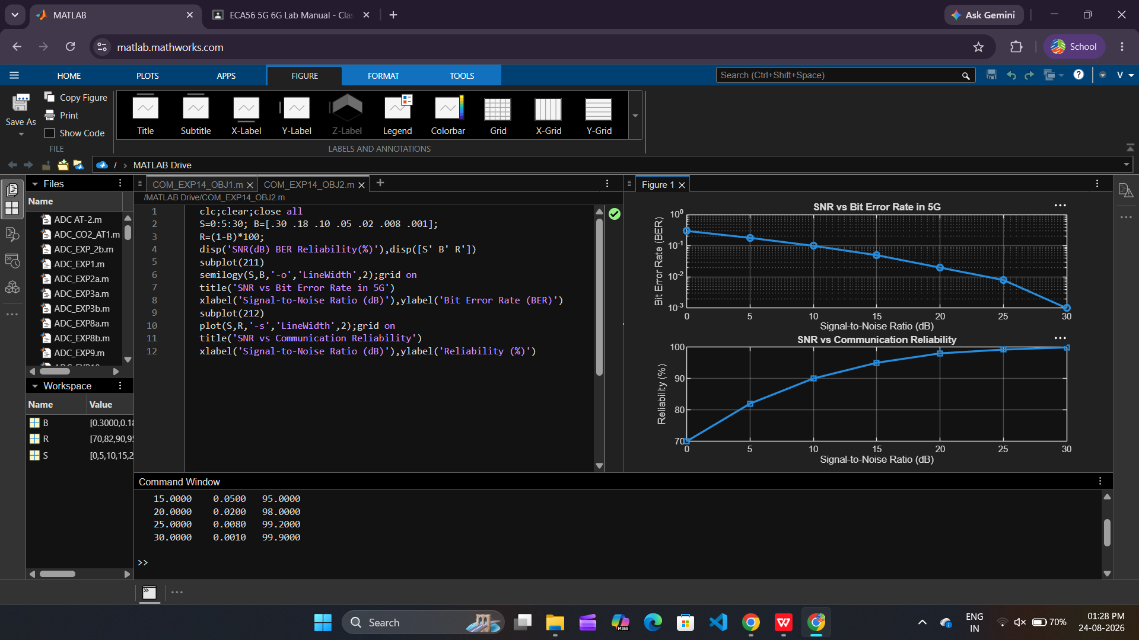

Objective 3: To compare the performance of different Modulation Schemes (QPSK, 16-QAM, 64-
QAM, and 256-QAM) and determine their suitability for varying SNR conditions.

Matlab Code:

clc;clear;close all
M={'QPSK','16-QAM','64-QAM','256-QAM'};
S=[5 10 18 25]; E=[2 4 6 8];
disp(table(M',S',E','VariableNames',{'Modulation','SNR_dB','Efficiency'}))
subplot(212)
plot(S,E,'-o','LineWidth',2);grid on
title('SNR vs Spectral Efficiency')
xlabel('Signal-to-Noise Ratio (dB)'),ylabel('Spectral Efficiency (bits/s/Hz)')
subplot(211)
plot(1:4,S,'-s','LineWidth',2);grid on
xticks(1:4),xticklabels(M)
title('Required SNR for Different Modulation Schemes')
xlabel('Modulation Scheme'),ylabel('Required SNR (dB)')

